1. Sorting: Comparator:
#code:
import java.util.*;

// HackerRank provides this class in the background/stub
class Player {
String name;
int score;

Player(String name, int score) {
this.name = name;
this.score = score;
}
}

// This is the custom comparator you need to implement
class Checker implements Comparator<Player> {
@Override
public int compare(Player a, Player b) {
// 1. Sort by score in descending order
if (a.score != b.score) {
return Integer.compare(b.score, a.score);
}
// 2. If scores are equal, sort alphabetically by name
return a.name.compareTo(b.name);
}
}

// This runs the test cases
public class Solution {
public static void main(String[] args) {
Scanner scan = new Scanner(System.in);
int n = scan.nextInt();

Player[] player = new Player[n];
Checker checker = new Checker();

for(int i = 0; i < n; i++){
player[i] = new Player(scan.next(), scan.nextInt());
}
scan.close();
Arrays.sort(player, checker);
for(int i = 0; i < player.length; i++){
System.out.printf("%s %s\n", player[i].name, player[i].score);
}
}
}
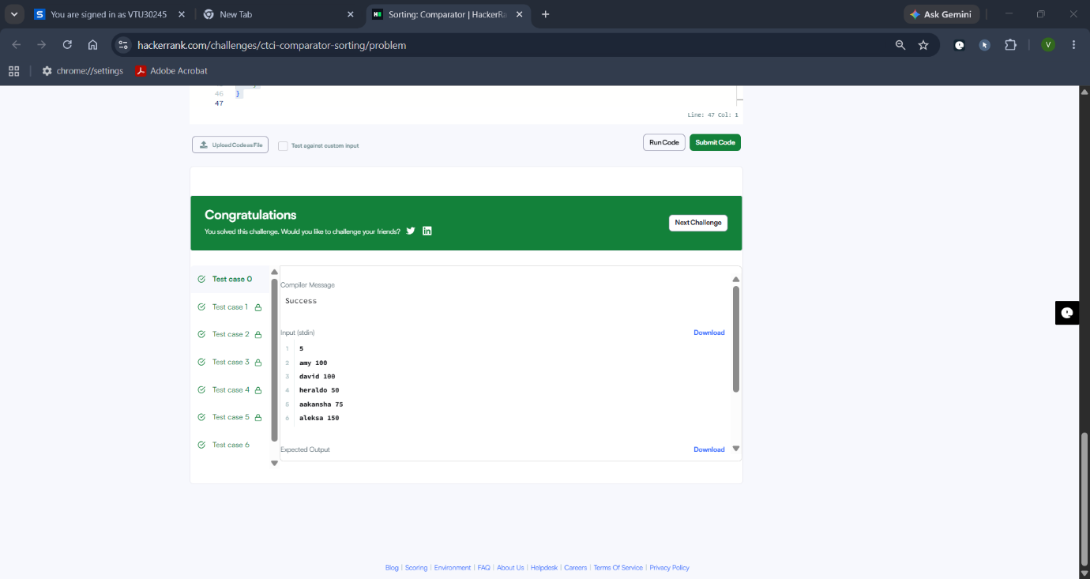
2. Java Comparator:
#code:
import java.util.*;

class Player {
String name;
int score;

Player(String name, int score) {
this.name = name;
this.score = score;
}
}

class Checker implements Comparator<Player> {
@Override
public int compare(Player a, Player b) {
if (a.score != b.score) {
return Integer.compare(b.score, a.score);
}
return a.name.compareTo(b.name);
}
}

public class Solution {
public static void main(String[] args) {
Scanner scan = new Scanner(System.in);
int n = scan.nextInt();

Player[] player = new Player[n];
Checker checker = new Checker();

for (int i = 0; i < n; i++) {
player[i] = new Player(scan.next(), scan.nextInt());
}
scan.close();

Arrays.sort(player, checker);
for (int i = 0; i < player.length; i++) {
System.out.printf("%s %s\n", player[i].name, player[i].score);
}
}
}

